Removing the filaments in a PHI 04-548 or 04-500 X-ray Source: New Style Filaments
The Physical Electronics 04-548 and 04-500 are popular 15kV dual anode X-ray sources and need periodic maintenance which includes:
- Replacing the Aluminum window………… | RBD Part Number 602508PR
- Replacing the Filaments………………………. | RBD Part Number 622275RE
- Replacing the football ceramic……………. | RBD Part Number 602229PR
- Cleaning or replacing the Anode…………. | RBD Part Number 04548XRSR  (anode recoating service)

This procedure and video will explain and show the steps required to disassemble the X-ray source.
Tools required:
5/8" and 9/16" open end combination wrench
9/16" and ½" open end combination wrench
1/2" and 7/16" open end combination wrench
1/4" and 5/16" box end combination wrench
Small straight head screwdriver
Small Philips head screwdriver
096-6 Bristol wrench
048-4 Bristol wrench
Needle nose pliers
3/16" Allen wrench
9/64" Allen wretch or 168-6 Bristol wrench
Tweezers
0-80 screw or threaded rod
Gloves
Aluminum foil
Kim wipes
Isopropanol

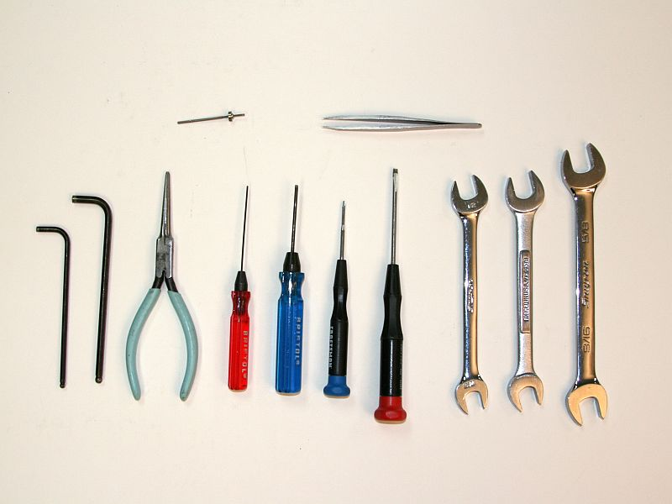
Note: If you do not have Bristol wrenches you can get them from places like McMaster Car or directly from Bristol at http://www.bristolwrench.com/ phone number 503-371-9655

Procedure
- Vent system and remove X-ray source from vacuum chamber. You can leave the X-Y-Z bellows attached to the chamber and just remove the source from the top flange on the X-Y-Z bellows.
- Prepare a spot on a table top by laying down some clean aluminum foil and place the source on the table top. Clean your tools with isopropanol.
- Remove the screws from one of the source covers so that you can access the water lines, remove the cover and remove the Teflon shield. Then loosen the larger 5/8" ferrules so that you can disconnect the water lines that run from the water couplers to the source.
- Remove the screws from the other cover and then remove the screw that connects the high voltage connector to the anode. Usually there is a 1K ohm 15kV resistor in series with that connection.
- Remove the remaining shield and coupler flange.
- Remove the remaining water lines (if any, some of the older sources only have one set of water lines).
- Drain the water out of the source into a sink or waste basket.
- Remove the 6 cap head screws that hold the anode in place. Note the position of the anode in and out lines with respect to the filament connector. On most systems, the exit line with be pointing away from the filament connector. Pull the anode out and place it on the aluminum foil. Use gloves when handling the anode.
- Using a 096-6 Bristol wrench, remove the 4 screws that hold the end cap in place and remove the end cap. Be careful as you pull the end cap off as the filament retainer pins may fall out.
- Remove the 2.75" filament connector access flange by unscrewing the six 3/16" Allen head screws.
- Using the needle nose pliers and 048-4 Bristol wrench (RBD provides long version of this wrench that works well for this specific purpose) loosen the filament coupler set screws by turning them CCW a few turns. They do not need to be removed completely.
- Remove the filament retainer pins using the 0-80 screw.
- Remove the filaments by pulling them straight out of the source. The filament wires and ceramic tubes will come out with the filaments.
- Remove the moly shield pins using the 0-80 screw. These are usually pretty tight and you may need to use the needle nose pliers to get some leverage.
- Remove the moly shield by working it back and forth as you pull on it. If it is really tight you can use some isopropanol as a lubricant.
- Remove the football ceramic pins using the 0-80 screws. These are also usually pretty tight.
- Remove the football ceramic by using the needle nose pliers and gently working the ceramic back and forth while moving it forward and out.
- Finally, remove the aluminum window from the end cap by using a tweezers to pull the retainer clip out. On some of the older sources that are used on double pass CMA system there will be a collimator shield as well as the retainer clip. Once the clip is removed you can push the window out of the end cap.
The source is now completely disassembled and ready to put new parts in.
Note: For most maintenance you will not need to completely disassemble the source. For example, if you only need to replace the aluminum window, just pull the end cap off.
If you only need to replace one or both filaments, just pull the end cap off and remove the anode.
To place an order for replacement parts, please visit our website at www.rbdinstruments.com or by calling us at 541 550-5016

